# 



# School of InfoComm Technology

**Data Discovery & Visualisation**

Diploma in Cybersecurity & Digital Forensics

Diploma in Information Technology

April 2023 Semester

**ASSIGNMENT 1**

**(Individual Assignment)**

**Submission Deadline:**

**31 May 2023 (Wednesday), 2359 hrs**

|  |  |  |
| --- | --- | --- |
| **Tutorial Group** | **:** | **P01** |
| **Student Name** | **:** | Isaac Khoo |
| **Student Number** | **:** | S10244252C |
| **Video Link** | **:** | <https://youtu.be/hp3B614OeGU> |

**Penalty for late submission:**

10% of the marks will be deducted every calendar day after the deadline.

**NO** submission will be accepted after 7 June 2023 (Wednesday), 2359 hrs.

Contents

School of InfoComm Technology 1

Introduction 3

Stakeholder Background 3

Exploratory Questions 3

Booking pattern analysis 3

Date/Regional analysis 3

Guest service analysis 3

Data Preparation 4

Changes made to the data: 4

Exploratory Data Analysis 7

1. Booking Pattern Analysis 8

2. Date/Region Analysis 11

3. Guest Service Analysis 15

Dashboards 18

Reflections 20

# Introduction

In this assignment, I will be using the hotel bookings Dataset from a city hotel and a resort hotel to answer some questions that my stakeholder, the hotel management, should care about.

# Stakeholder Background

The Hotel management involves overseeing all aspects of a hotel's operations to ensure its smooth and efficient functioning. With many guests booking rooms every day, the hotel management makes sures of the overall operation and performance of the hotel. The Hotel management also ensures that the hotel meets its financial targets, maintains quality standards, and delivers exceptional guest experiences.

# Exploratory Questions

### Booking pattern analysis

1. What is the average price per month in each hotel?
2. What is the turnover rate of bookings made by guests?
3. Are the bookings mostly made through a third party (Agent/Company/etc.) or directly by guests?
4. On average, how long do customers need to wait for confirmation in each distribution channel?

### Date/Regional analysis

1. What is the overall trend in hotel bookings over the past years?
2. Are there any seasonal patterns in hotel bookings?
3. Are there specific regions or countries that contribute significantly to the hotel's customer base?
4. Which hotel is more sought after by guests.

### Guest service analysis

1. Do guests prefer certain meal types offered by the hotel?
2. Do guests who stay at the hotel have their own mode of transportation?
3. Do guests who stay at the hotel like to make special requests?
4. How many guests that received the room type they reserved?

# Data Preparation

The state of the data is not the most completed and requires some additional working and information to deal with such that I will be able to identify and use the data easier during the visualisation process. I do expect to make some changes to the data such that I will be able to use the data easier during the visualisation process.

### Changes made to the data:

1. T/F

IF[Reserved Room Type] = [Assigned Room Type] THEN "T" ELSE "F" END

This helps check if the room type that the guest booked is the same room type that is assigned to the guest.

1. Days Stayed  
   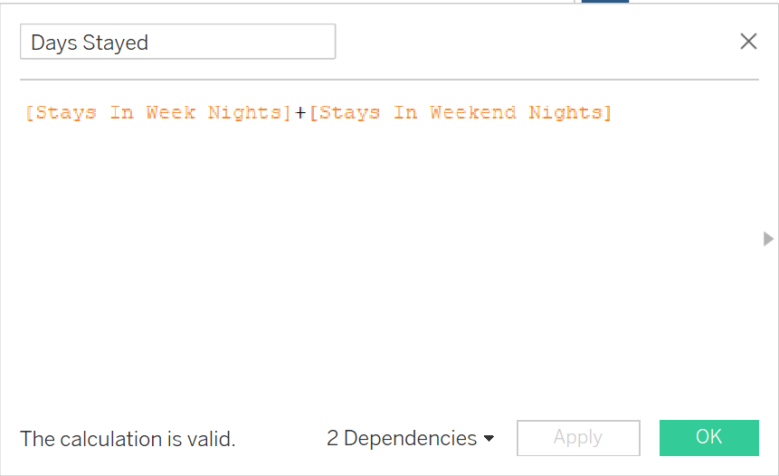  
   [Stays In Week Nights]+[Stays In Weekend Nights]

This adds up the nights stay for weekday and weekends so as to get a total number of days stayed.

1. Direct Booking  
   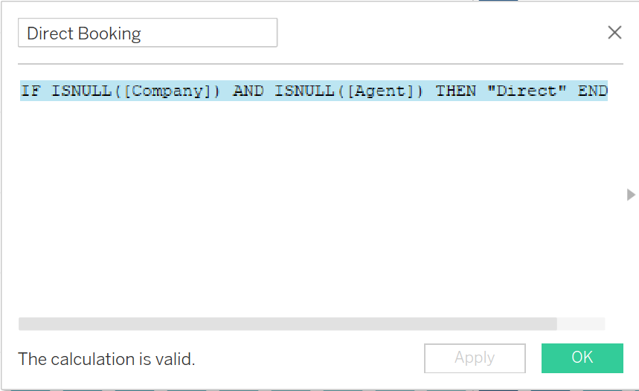

IF ISNULL([Company]) AND ISNULL([Agent]) THEN "Direct" END  
  
This checks if the booking is not Company or Agent Then the booking is a direct booking.

1. Number of reservations 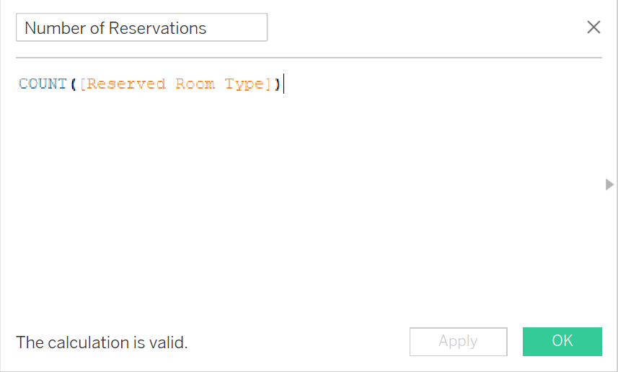

COUNT([Reserved Room Type])  
This takes the Total Count of the Reserved Room Type to be able to see the total number of reservations made.

1. Total Bookings 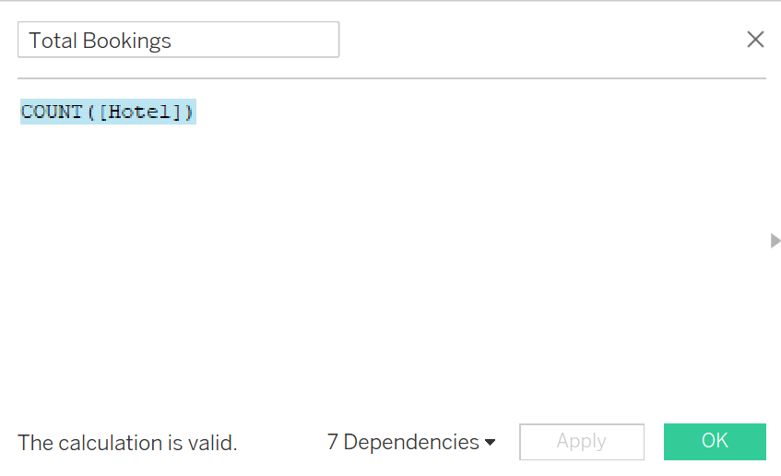

COUNT([Hotel])  
This is to measure the total count of the Hotels so as to be able to see the Total number of bookings.

1. Total Number of guests 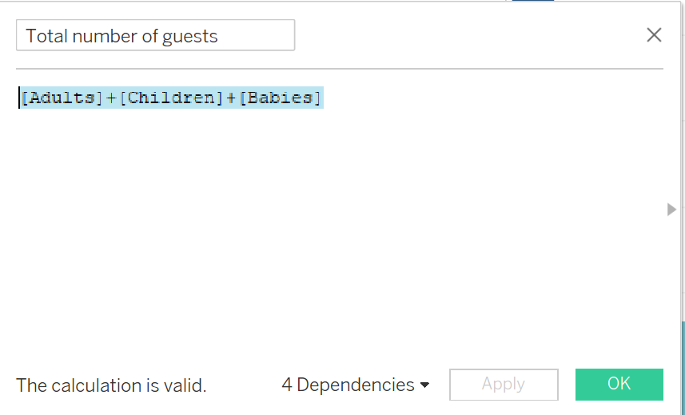

[Adults]+[Children]+[Babies]

This is to find the total number of guests in the room by adding the number of Adults, Children and babies

# Exploratory Data Analysis

Exploratory Data Analysis refers to the process of performing initial investigations of data to discover patterns, spot anomalies, test hypotheses and check assumptions with the help of summary statistics and graphical representations.

**Visualisations**

## Booking Pattern Analysis

1. What is the average daily price per month in each hotel

Fig 1.1 Shows a side-by-side bar chart showing the trend of the average daily price per month in both the city and resort hotel in descending order. The darkness of the blue also shows the increase in the price per month for the hotels. This chart aims to show the stakeholders about the months in which the hotel makes the most money through the average daily price for each month. From this chart we can conclude that May is the best month in which the City hotel makes the most from the daily price while August is the best month in which the Resort Hotel makes the most from the daily price. This chart can help show the stakeholders which month to focus more events and incentives on as these are the months where demand for the hotel is higher.

1. What is the turnover rate of bookings made by guests?

Figure 1.2 shows a donut chart which displays the total number of bookings in the middle whilst each slice of the donut chart shows the percentage of total bookings in which the reservations are Cancelled, Checked-out or a Now-Show. This chart aims to show the stakeholders how many people actually go through with their orders or how many actually end up backing out for whatever various reasons they have. From This chart we can see that a majority of the reservations are actually followed through with. However there is still a decent portion of people who cancel their booking. This will help the stakeholders understand that there still is a decent amount of people cancelling their booking and leads them to want to start taking action to try and prevent this from happening.

1. Are the bookings mostly made through a third party (Agent/Company/etc.) or directly by guests?

Figure 1.3 shows a pie chart showing the different form of bookings whether 3rd party or direct as a percentage reflection of the total bookings made. This chart aims to show the stakeholders where the main portion of their customers actually book their bookings from. This will help the stakeholders know where they need to improve in their advertising or promoting to help boosts the others whilst at the same time be able to offer more incentives on the more used market segments so as to pull even more people into wanting to make a booking too.

1. On average, how long do customers need to wait for confirmation in each distribution channel?

Figure 1.4 shows a side by side bar charts which shows how long on average per year each customer has to wait for their confirmation using the distribution channels. This chart aims to show the stake holders an idea of the amount of time each customer has to wait in the waiting list before getting their confirmation and which distribution channels they used. As a result, Stakeholders will be able to see if the hotel needs to speed up their production so as to free up more space to enable the guests waiting on these waiting lists a lesser waiting time for confirmation.

## Date/Region Analysis

1. What is the overall trend in hotel bookings over the past years? A picture containing text, screenshot, diagram, plot

   Description automatically generated

Figure 2.1 Shows an Area Chart which shows the bookings for the months in each year with a filter where you will be able to filter each year. The values for the number of bookings per month is displayed for each month. The chart aims to let the stakeholders know total number of bookings made per year and at the same time the volume and value of the bookings per month of each year. This will help the stakeholder keep track of their hotel bookings and help them notice any decreases

or increases. They willl also be able to use this data to figure out which months are more sought after so as to create and put a system in place to make the most out of it.

1. Are there any seasonal patterns in hotel bookings? A picture containing text, screenshot, rectangle, square

   Description automatically generated

Figure 2.3 Shows a Treemap showing the different months. The colours orange to blue diverging to show the volume of bookings coming in per month with dark blue showing a lower volume while dark red shows a higher volume. This will help the Stakeholders identify which group of months have a higher/lower order volume which will give them an idea of when to start doing promotions/incentives to further incentivise the people/guests to want to book more.

1. Are there specific regions or countries that contribute significantly to the hotel's customer base?A map of the world

   Description automatically generated

Figure 2.3 Shows a symbol map where a map of all the countries are shown. The countries with bookings are highlighted and the darker the highlight the higher the number of bookings coming from the country. This will help the stakeholders identify if there is any specific countries in which more orders are actually coming from. This can let them set up campaigns or travel packages for those countries to further make the people want to book and stay at their hotel.

1. Which hotel is more sought after by guests? A picture containing text, diagram, line, plot

   Description automatically generated

Figure 2.4 shows a dual line graph which shows the bookings made for each line represents hotels for total bookings each month. This shows to the stakeholders the trend of which the bookings are made for each month for both hotels. And also helps compare the total bookings per month of both hotels. The stakeholders will be able to identify which hotel is doing better and figure out ways to upsell the hotels to improve sales and increase revenues. This is also a good way for the stakeholders to see if there are changes are needed in order for better results and could also reward the departments for better results.

## Guest Service Analysis

1. Do guests prefer certain meal types offered by the hotel? A picture containing screenshot, text, circle, diagram

   Description automatically generated

Figure 3.1 shows a packed bubbles chart which shows the guest demand in the types of meals offered by the hotels. This shows to the stakeholders which meal package guests are mostly want. This can help the stakeholders gauge on possibly increasing prices on some bundles and decreasing prices on other bundles so as to more incentives guests to want to purchase these meal types.

1. Do guests who stay at the hotel have their own mode of transportation? A picture containing text, screenshot, number, line

   Description automatically generated

Figure 3.2 shows a Box and Whiskers diagram shows us the median to forecast the trend, we can see the end of box which is around 300. This will help informate the stakeholders on the number of hotel spaces in which the they should prepare for the guests to use. As a result, they will be able to prepare in advance for the guests demanding hotel parking slots.

1. Do guests who stay at the hotel like to make special requests? A picture containing text, screenshot, plot

   Description automatically generated

Figure 3.3 shows an area chart which shows the volume of special request made each day of every month for a year. The different areas are represented by the volume made each month and you will be able to directly see the number of special requests made in each particular day. This will help the Stakeholders to prepare extra resources on months in which there seems to be a larger number of special requests made by guest. This will help appease the guest which can help increase the hotels overall reputation as a whole as a very accommodating and good hotel.

1. How many guests that received the room type they reserved? A picture containing screenshot, text, diagram

   Description automatically generated

Figure 3.4 shows a pie chart shows the percentage of guests who managed were assigned the room type in which they reserved. This helps the stakeholders know that a majority of the guests are able to get the room of their choice. However there are still a small portion of guests who were not able to be assigned to their room reservation of choice. As a result, the stakeholders may try to combat this problem by hiring more housekeepers to clean rooms faster to sell the rooms or invest into building more rooms overall finding a way to help ensure that a higher portion of reservations are assigned to the room type they booked.

# Dashboards

This figure shows the Booking Pattern Analysis dashboard. This dashboard consists of 4 different visuals on how to represent the patterns in the hotels bookings.

The 4 visuals include:

1. Side-by-Side Chart
2. Donut Chart
3. Pie Chart
4. Side-by-Side Chart

This figure shows the Date/Region Analysis Dashboard. This dashboard consists of 4 different kinds of visuals on how to represent the Date and Regions data in hotel bookings.

The 4 visuals include:

1. Area Chart
2. Treemap
3. Symbol Map
4. Dual Line Graph

This figure shows the Guest Service Analysis Dashboard. This dashboard consists of 4 different kinds of visuals on how to represent the trends and demands in the guest service data of hotel bookings.

The 4 visuals include:

1. Packed Bubble Diagram
2. Box-And-Whiskers Diagram
3. Area Chart
4. Pie Chart

# Reflections

Throughout this assignment I have approached many people for help be it friends, seniors or teachers and I have really felt my learning evolve and actually increase my ceiling when it comes to using tableau. Everything I learned here I do intend on using in the future especially when it comes to analysing the data and coming up with questions. I feel that it is and will be very important skill as I do feel that with this ability to come up with questions it really shows how much you actually do understand the data and the ability to manipulate it. Although I do feel like I should have done more in cleaning the data (currently learning data cleaning In Applied analytics module) I do feel that I will be using this skill of cleaning data in the future for assignments as the ability to be able to clean and simplify the data will really help you use and visualise the data better. Some challenges I did encounter when doing this assignment is that when it came to visualising data I really had to try and come up with creative ideas to visualise the data and make it easier to read. A big part of this I feel is due to the lack of cleaning of data. Which brings me to my second challenge which is cleaning the data. We weren’t really taught much on how to clean the data but I managed to solve quite a few problems with the calculation fields which really made my life more convenient. In conclusion, I do hope to learn more and do well for this assignment and the rest of this module.